### Technological Institute of the Philippines Quezon City

College of Engineering and Architecture Computer Engineering Department

**ROUTE 88 BIKE CAFÉ’S POS SYSTEM**

Hernandez, Brenda

Licas, Janrey

Mascareñas, Charles Ian

Moreno, Jan Patrick G.

CPE21FB1

Submitted to:

Engr. Royce Chua

August 28, 2019

# ABSTRACT

Discuss a summary of the entire project here (250 words only)

# List of Figures

Figure 1.1 The Engineering Design Process (always add figure numbers for any images) ........................... 7

Figure 2.1 Illustrative Diagram ..................................................................................................................... 10

# List of Tables

Table 2-1 Software Dependencies................................................................................................................. 9

Table 2-2 System Requirements ................................................................................................................... 9

### TABLE OF CONTENTS

ABSTRACT 2

List of Figures 3

List of Tables 4

CHAPTER 1: THE PROJECT AND ITS BACKGROUND 6

1.1 The Client 6

1.2 The Problem 6

1.3 The Project 6

1.4 Project Constraints 6

1.5 Standards 6

1.6 Engineering Design Process 7

CHAPTER 2: THE SYSTEM DESIGN 9

2.1 Overview of the System Design 9

2.2 System Specification 9

2.3 Illustrative Diagram 10

2.4 System Block Diagram 10

2.5 System Flowchart 10

2.6 Management Plan 10

CHAPTER 3: FINAL SYSTEM DESIGN 11

3.1 Testing and Evaluation Methods 11

3.2 Impact of the Developed System 11

3.3 Conclusion 11

APPENDICES 12

APPENDIX A: TEAM PROFILE 12

APPENDIX B: SYSTEM SCREENSHOTS 12

APPENDIX C: PROJECT REPOSITORY LINK 12

REFERENCES 13

# 

# CHAPTER 1: THE PROJECT AND ITS BACKGROUND

Our project is all about Route-88 Bike Café POS System. It’s a business operation started last June 2015 and it is located at 88-A Anonas Street, Brgy. East Kamias Quezon City. As their venture progresses, the café managed to cater all the demands of the people. However, at the same time due to increase in sales they experience issues in managing their sales and stocks. To address this problem, the owner wants their data to be maintained automatically through a computer. Our group will develop a software called POS system. To store all the information about the café’s sales status which can be accessed with ease.

## 1.1 The Client

Our client name is Czarina Clemente. She is the owner of the Route-88 Bike Café. which offers affordable and delicious meals. Also, this café is a food joint inspired for cyclists. Most of the problems that they encountered based on the client, that the manual transactions it is hard to monitor and to keep track of their stocks. For instance, they experience having excessive stocks and sometimes lose stocks. Manual counting is also prone to error.

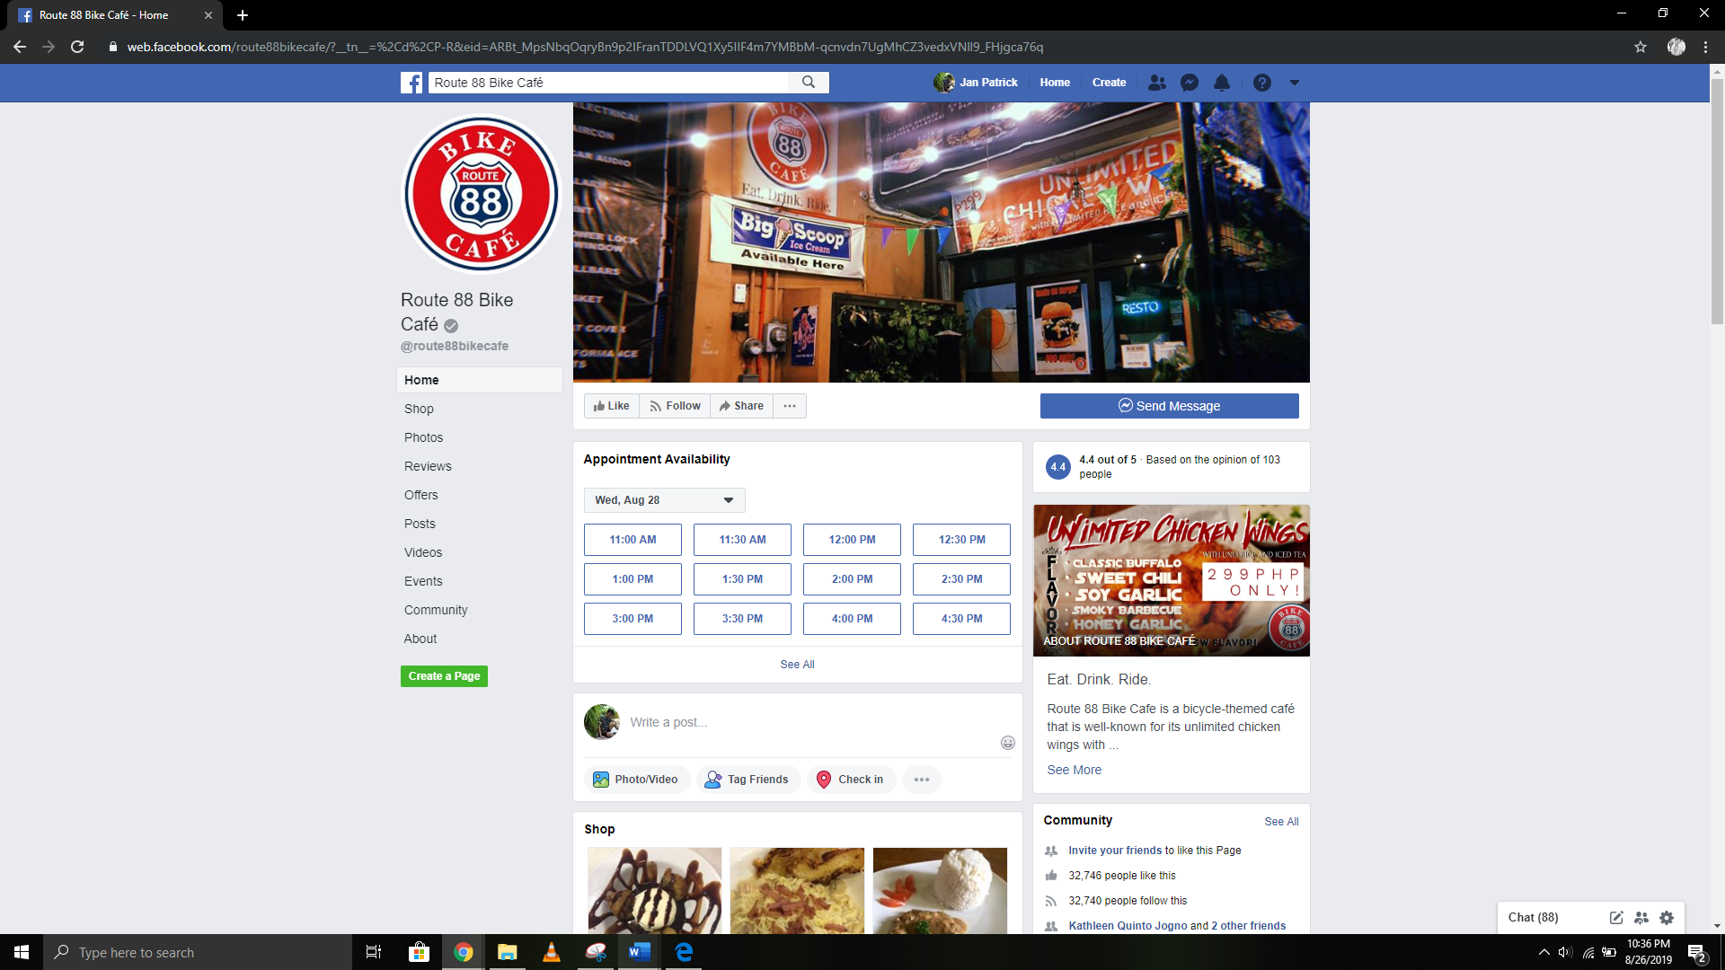

## 1.2 The Problem

The main problem of our client is to managing the sales and stocks. Due to increases their sales they experience issues in managing their sales and stocks. To address this kind of problem, the owner wants their data to be maintained automatically through a computer. Our group decided to develop a software called pos system or point of sales system. This system will store all the information of the café’s sales and stocks which can be accessed with ease.

## 1.3 The Project

The proposed project is a POS system or point of sale system that calculates the amount owed by the customer, indicates the amount, may prepare an invoice for the customer and to indicates the option for customer to make payment. We decided to develop this kind of software to store all the information of the café’s sales and stocks and to make the transactions of route-88 bike café efficient by maintaining their data.

### General Objective

The project's objective is to create a program that can make easy access for the owner to see their POS System due to its increasing sales over the years and they need a more organized and bigger database and to visualize the Route 88's Point-Of-Sales System.

### Specific Objectives

* POS system that is focused on sales
* Automatic creation of invoice
* Create a graphical representation of expenses
* Notify the owner if budget allocation exceeds.

## 1.4 Project Constraints

What are the constraints/limitations you might have considered in your project? (Ex. (Manufacturability Constraint - Time of Development, Economic Constraint - Cost like development costs and deployment costs, etc..)

## 1.5 Standards

What are the standards you used in the development of the project (Coding standards, Software engineering standards, etc… try to retrieve some from IEEE BUT USE PROPER APA CITATION for any references you will use)

## 1.6 Engineering Design Process

This section will discuss about how the Engineering Design Process was applied in the project.

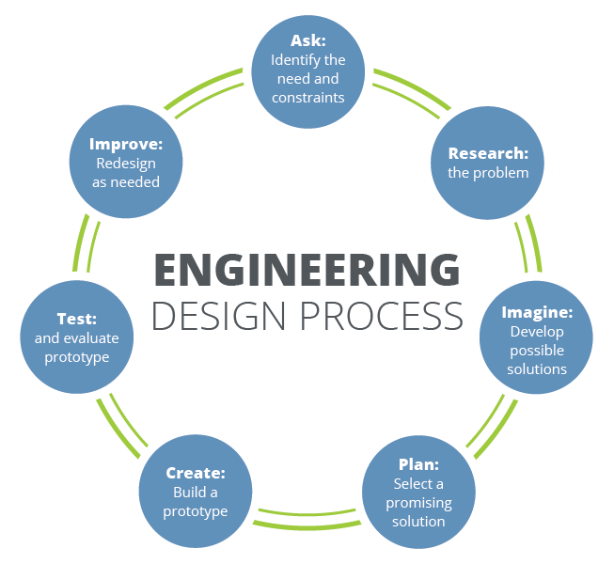

Figure 1.1 The Engineering Design Process (always add figure numbers for any images)

*Image source:* [*www.teachengineering.org*](http://www.teachengineering.org/)

**Ask: Identify the need & constraints**

Discuss how your team identified the need for this project and constraints (limitations) you might encounter.

### Research the problem

Discuss how your team researched problems related to that need like what existing alternatives are already present than what you think you might need to do. What did you research about when doing this project?

### Imagine: Develop Possible Solutions

Discuss how your team collaborated together to develop/formulate possible solutions/approaches to this need and problems. Kindly share some of the approaches your team thought of. What software development techniques or software design paradigms might have you considered in developing the Web or Desktop application? (Ex. Top-Down/Bottom-Up, Models View Controller Paradigm / Models Views Templates Paradigm)

### Plan: Select a Promising Solution

Discuss how your team chose the best/promising solution among the other alternatives (based from what? Some form of analysis? Based from?)

### Create: Build a Prototype

Discuss the final solution chosen, what did it consist of? What were the final functionality included in this project?

**Test: and Evaluate the System**

How did you test and evaluate your system? How did you validate that the specific objectives were satisfied?

### Improve: and Redesign as Needed

Discuss how you plan to improve on this project. How do you plan to scale this project if it will be purchased or adopted by the client.

# CHAPTER 2: THE SYSTEM DESIGN

Discuss the summary of contents to be found in this chapter. This is only 1-2 sentences. (replace all the contents here with your own, I do not want to see my comments still here when you submit)

## 2.1 Overview of the System Design

Discuss here the overview of your system design.

## 2.2 System Specification

Discuss the specifications of the system (components, dependencies, system requirements for the machines that will be hosting/using this project). You can modify this to your liking but these topics must be present.

### Software Dependencies

Discuss here the software dependencies. Table 2-1 shows….

Table 2-1 Software Dependencies

|  |  |  |
| --- | --- | --- |
| Software/Package |  | Version |
|  |  |  |
| **System Requirements**  Discuss here the system requirements. Table 2-2 shows….    Table 2-2 System Requirements | |  |
| Hardware/Software |  | Required Specification |
|  |  | |

**Software Editor (IDE)** What editor(s) does your team develop in? discuss briefly about the editor and why it was chosen.

## 2.3 Illustrative Diagram

Show here a graphical illustration of how the proposed system will work/function.

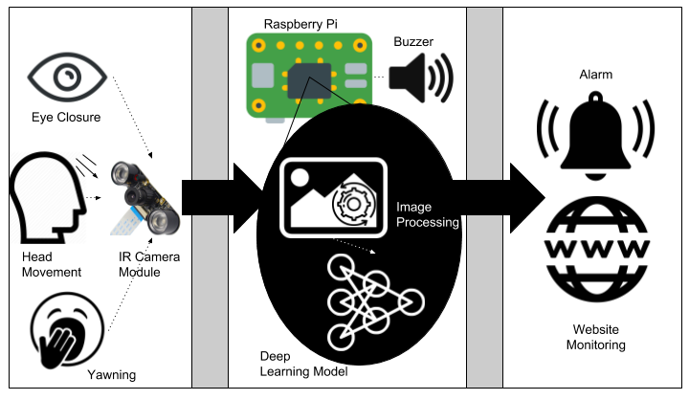

Figure 2.1 Illustrative Diagram

The illustrative diagram may involve the end-users, the main functionalities of the system, and the possible outputs of the system.

## 2.4 System Block Diagram

Show here the block diagram of the system (interaction of the major functionalities). Make sure to discuss the diagram.

## 2.5 System Flowchart

Show here the main flow of your system. You may or may not show all the details. Make sure to use the proper symbols.

## 2.6 Management Plan

How did your team manage the distribution of tasks? and code collaboration? how did you schedule your development time? If you used any software, system, or service like Google Drive, Git, Github/Gitlab, Trello, Slack, or similar. Discuss them here.

# 

# CHAPTER 3: FINAL SYSTEM DESIGN

Discuss the summary of contents to be found in this chapter. This is only 1-2 sentences. (replace all the contents here with your own, I do not want to see my comments still here when you submit)

## 3.1 Testing and Evaluation Methods

Discuss how you tested and evaluated the system that it accomplished the specific objectives mentioned in chapter 1.

## 3.2 Impact of the Developed System

Discuss how this project would benefit the client and other possible business that would need a system like this.

## 3.3 Conclusion

Write your conclusion about the project here.

# APPENDICES

# APPENDIX A: TEAM PROFILE

A detailed specification about the team leader, team members. Include the contribution of each member in the development of the project. It maybe in tabular format or bulleted format with the members 2x2 id picture included in the discussion of his or her contribution. A picture of the entire team formal attire or uniform attire must be present here.

# APPENDIX B: SYSTEM SCREENSHOTS

Show here the most important screenshots of your system (perhaps the major functionalities as stated in the specific objectives)

# APPENDIX C: PROJECT REPOSITORY LINK

Share here the project repository link URL if it is a Google Drive or Public GitHub Repository. If the project is private or contains sensitive information, provide instead an email of the team leader to contact that would grant the permission to view the project.

# REFERENCES

Narducci, M. (2017, May 19). City renames part of 11th Street Ed Snider Way to honor Flyers founder. The

Philadelphia Inquirer. Retrieved from <http://www.philly.com/>

This reference format can be found in more detail here: <http://www.citationmachine.net/apa/cite-a-book>(Delete this guide when finalizing your work)